DATABASE RELATIONSHIP ANALYSIS USING JOINS
Swiggy Instamart E-commerce platform

Objectives
1. Combine Customer, Product, Order, and Payment tables.
2. Implement INNER JOIN, LEFT JOIN, and RIGHT JOIN.
3. Retrieve complete order details.
4. Display customer purchase history.
5. Generate multi-table reports.

1.Combining Multiple Tables

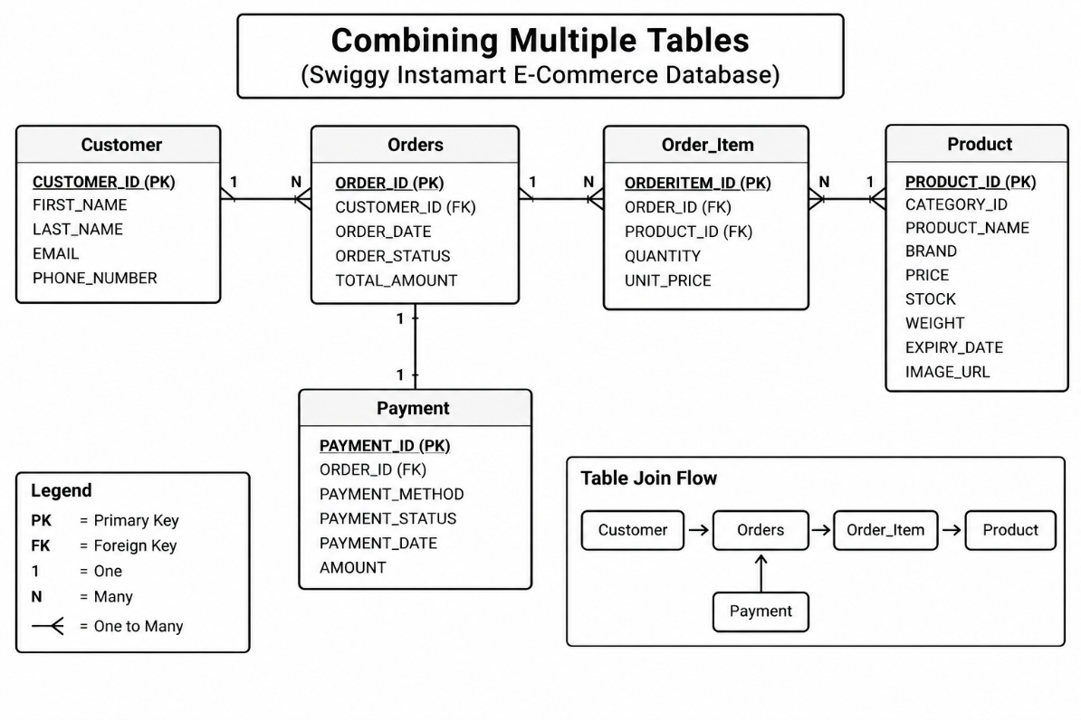

2. INNER JOIN
INNER JOIN returns only the records that have matching values in both tables.
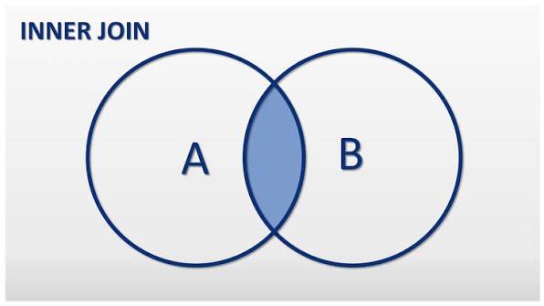

2.1 Customer and Orders
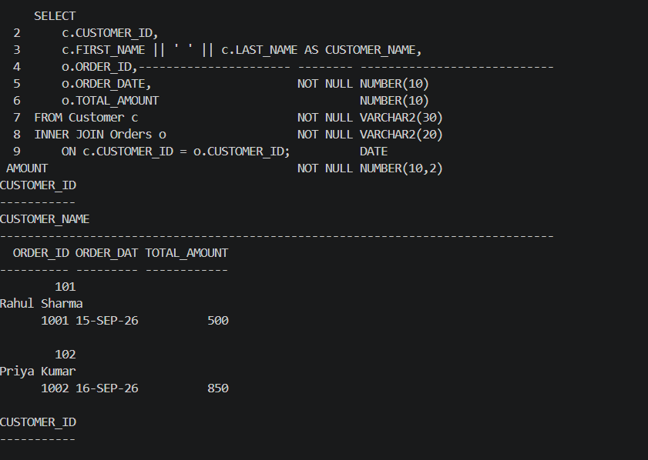

2.2 Orders and Payment
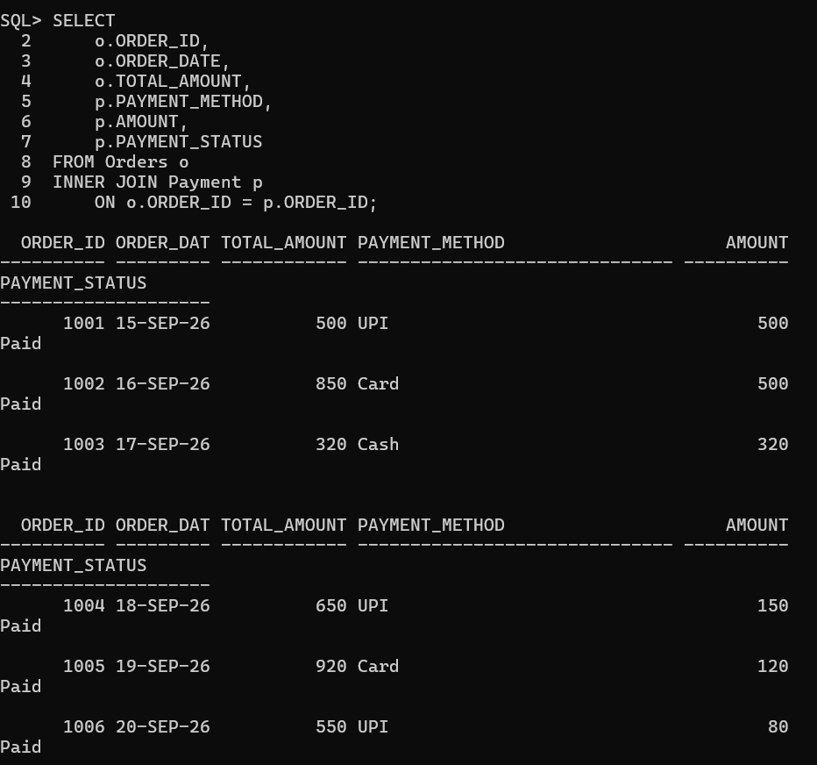

2.3 Product and Order_Details
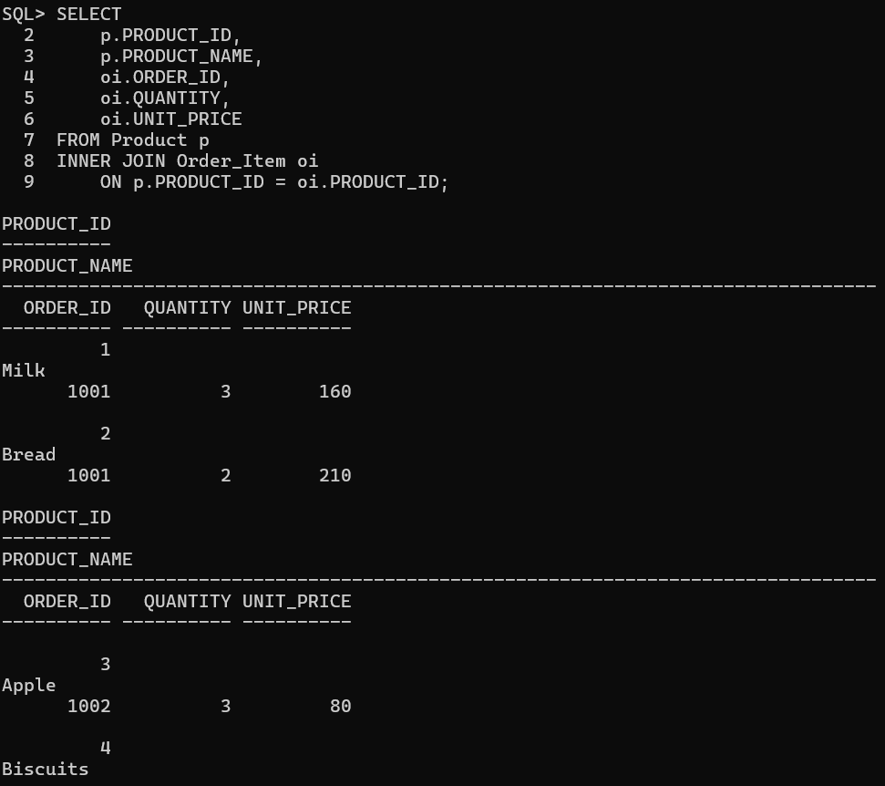

3. LEFT JOIN
LEFT JOIN returns all records from the left table and matching records from the right table.
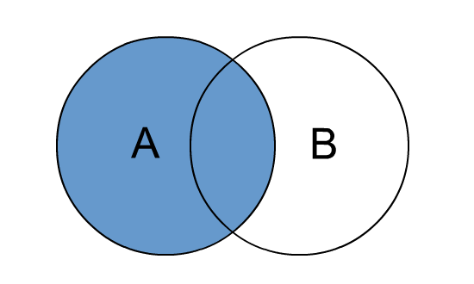

3.1 Display All Customers and Their Orders
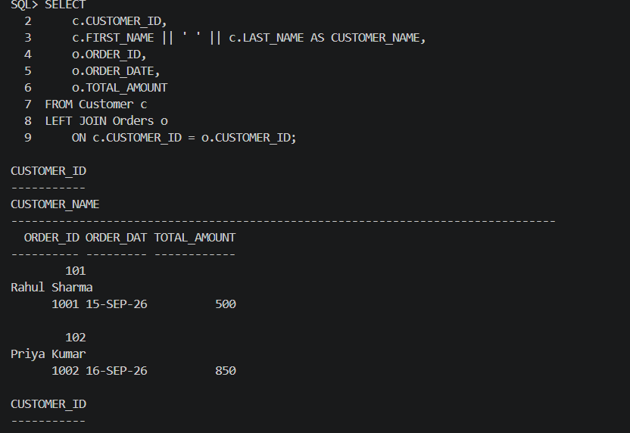

4. RIGHT JOIN
RIGHT JOIN returns all records from the right table and matching records from the left table.
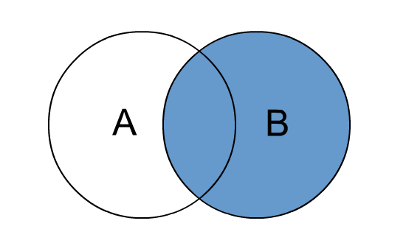

4.1 Display All Orders and Customer Details

5. Complete Order Details
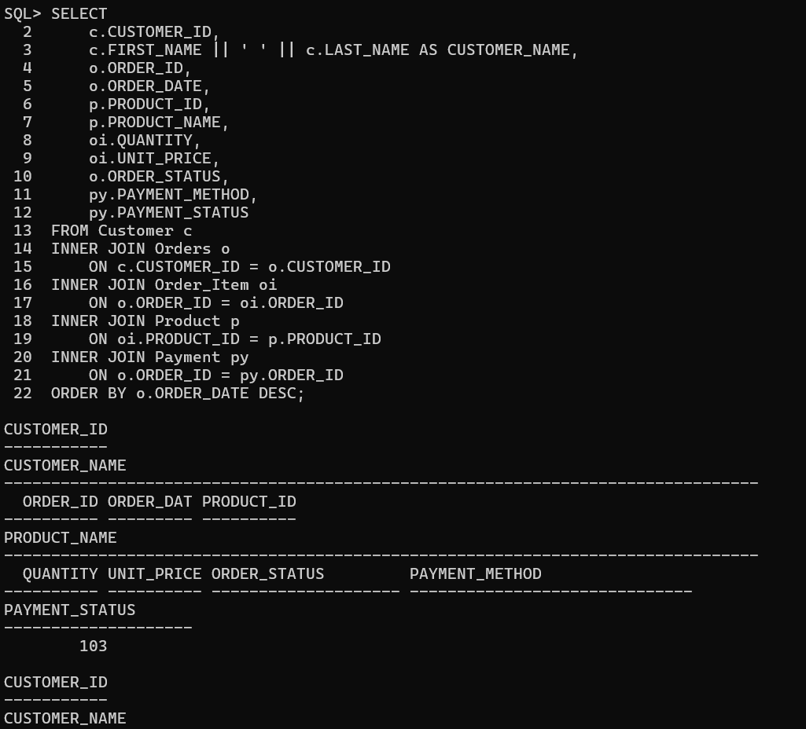

6. Customer Purchase History
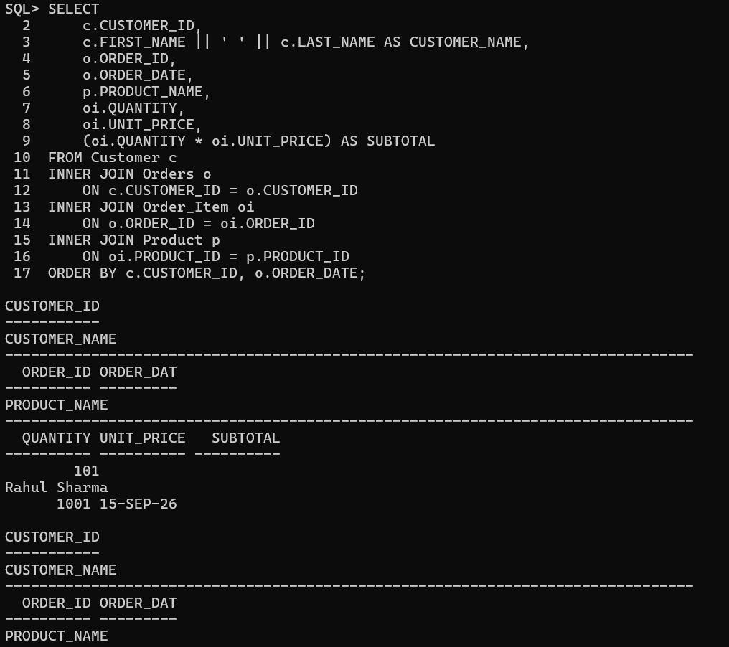

7. Customer Purchase History with Payment
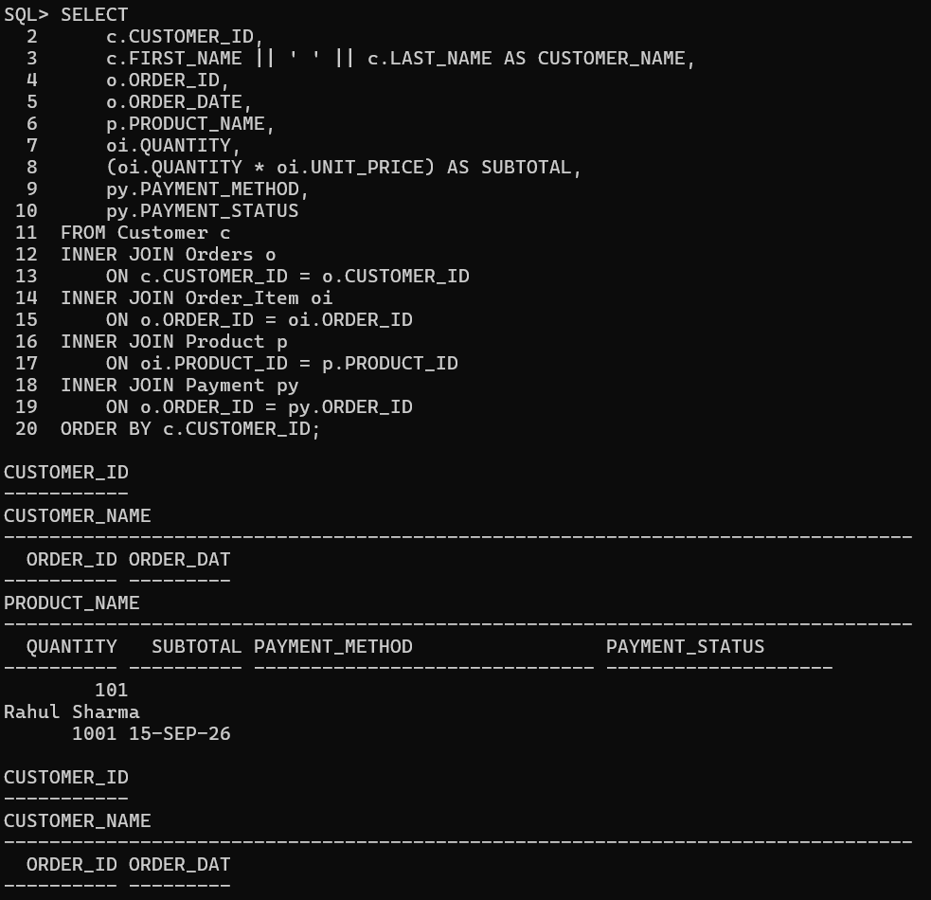

8. Multi-Table Business Report8. Multi-Table Business Report
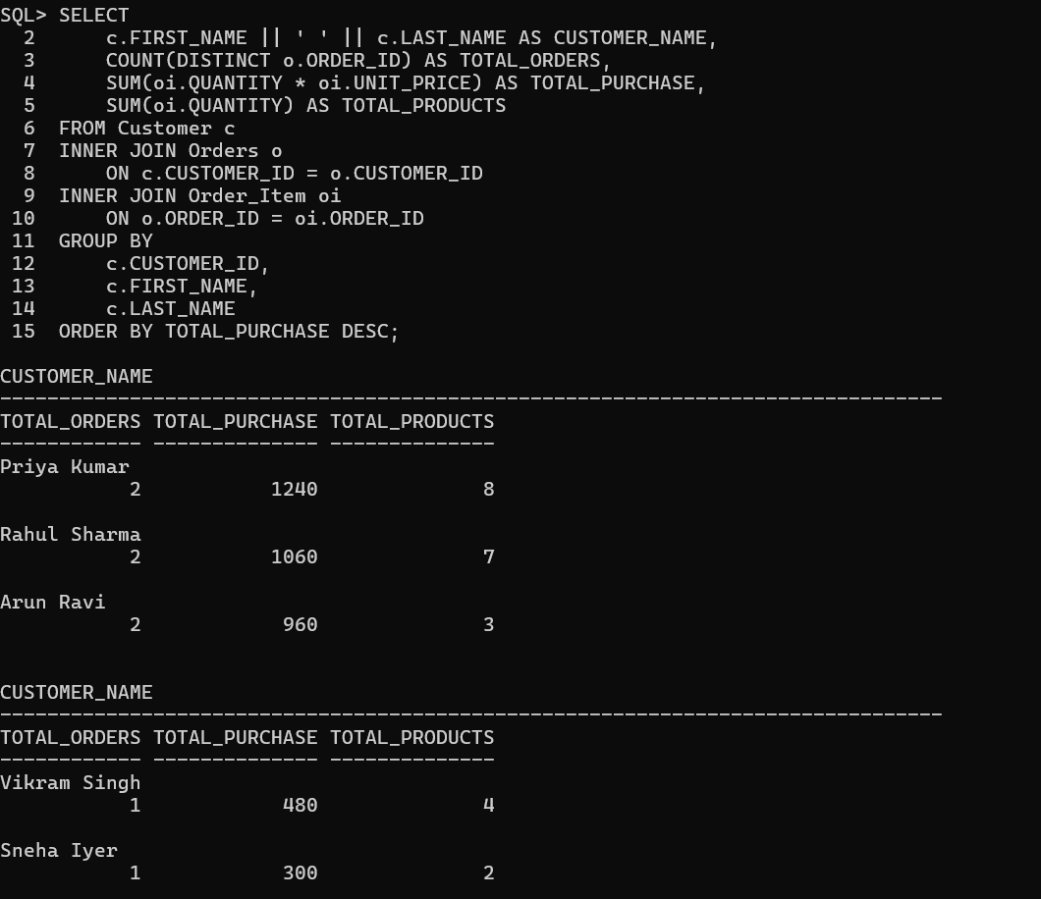

9. Payment Transaction Report
